**DAILY ONLINE ACTIVITIES SUMMARY**

|  |  |  |  |  |  |  |  |
| --- | --- | --- | --- | --- | --- | --- | --- |
| **Date:** | **18/05/2020** | | | | **Name:** | **Imran Khan** | |
| **Sem & Sec** | **8th A** | | | | **USN:** | **4AL16CS040** | |
| **Online Test Summary** | | | | | | | |
| **Subject** | | **SMS** | | | | | |
| **Max. Marks** | | **60** | | **Score** | | **45** | |
| **Certification Course Summary** | | | | | | | |
| **Course** | **Angular and node js –The mean stack** | | | | | | |
| **Certificate Provider** | | | **Udemy** | **Duration** | | | **20hrs** |
| **Coding Challenges** | | | | | | | |
| Problem Statement: Using methods charAt() & length() of String class, write a program to print the frequency of each character in a string. “Hello friend”. | | | | | | | |
| **Status: Solved** | | | | | | | |
| **Uploaded the report in Github** | | | | **yes** | | | |
| **If yes Repository name** | | | | **Imran040** | | | |
| **Uploaded the report in slack** | | | | **yes** | | | |

**Online Test Details:**

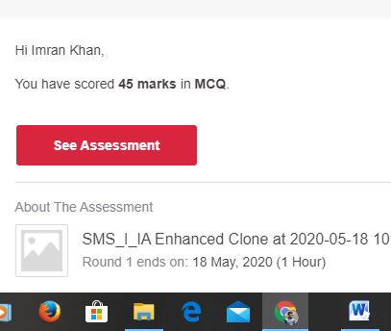

**Certification Course Details**:

Learn how to connect your Angular Frontend to a NodeJS & Express & MongoDB Backend by building a real Application

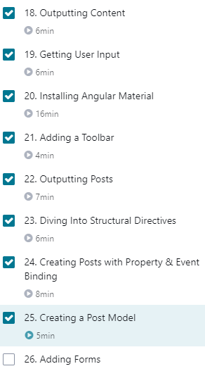

**Coding Challenges Details**:

**program1:**

|  |
| --- |
|  |
|  | static StringBuilder object = new StringBuilder(""); |
|  |  |
|  | public static void main(String[] args) throws InterruptedException { |
|  |  |
|  | Thread t1 = new PingPong(); |
|  | Thread t2 = new PingPong(); |
|  |  |
|  | t1.setName("\nping"); |
|  | t2.setName(" pong"); |
|  |  |
|  | t1.start(); |
|  | t2.start(); |
|  | } |
|  |  |
|  | @override |
|  | public void run() { |
|  | working(); |
|  | } |
|  |  |
|  | void working() { |
|  | while (true) { |
|  | synchronized (object) { |
|  | try { |
|  | System.out.print(Thread.currentThread().getName()); |
|  | object.notify(); |
|  | object.wait(); |
|  | } catch (InterruptedException e) { |
|  | e.printStackTrace(); |
|  | } |
|  | } |
|  | } |
|  | } |
|  | } |

2.

|  |
| --- |
| package pk; |
|  | import java.util.Scanner; |
|  | public class StringOperators |
|  | { |
|  | public static void main(String args[]) |
|  | { |
|  | int i; |
|  | String str; |
|  |  |
|  | int counter[] = new int[256]; |
|  | Scanner in = new Scanner(System.in); |
|  |  |
|  | System.out.print("Enter a String : "); |
|  | str=in.nextLine(); |
|  |  |
|  | for (i = 0; i < str.length(); i++) { |
|  | counter[(int) str.charAt(i)]++; |
|  | } |
|  | // Print Frequency of characters |
|  | for (i = 0; i < 256; i++) { |
|  | if (counter[i] != 0) { |
|  | System.out.println((char) i + ":-" + counter[i] + " times"); |
|  | } |
|  | } |
|  | } |
|  | } |